COMP315 – SEMESTER PROJECT
PROJECT FINAL REPORT
Multi-Threaded Real-Time Inventory & Trading System

StationaryHub

Member Name | Student ID | Role | % Contribution
Bandile Mhlambu | 223022585 | Project Manager | 14.28%
Sbonelo Ntshangase | 223012027 | STL & Data Structures | 14.28%
Lerato Mbhele | 221053528 | UI Design & Memory Management | 14.28%
Bongani Ntshumayelo | 222128837 | Software Code | 14.28%
Lindokuhle Machangu | 221032601 | Unit Testing & Logic Implementation | 14.28%
Andile Mthembu | 223043890 | Documentation | 14.28%
Sthembiso Mchunu | 224144451 | Class and System Architecture Design | 14.28%

1. System Introduction1.1 System Overview
The StationaryHub Inventory and Trading System is a high-performance, multi-warehouse inventory management solution developed in C++ to coordinate stock across nine regional warehouses in South Africa. The system manages stationery products such as calculators, pens, pencils, and exercise books, and processes high-volume customer orders using a concurrent execution model. Each warehouse maintains its own stock levels and storage capacity, and administrators can add, remove, and update products while ensuring capacity constraints are respected.
The project had three primary objectives: to apply advanced Object-Oriented Programming principles through a polymorphic product hierarchy that handles complex pricing logic (tax, discounts, and bulk rates); to leverage STL containers and algorithms for safe and efficient inventory management; and to implement multithreading to handle large volumes of simultaneous customer orders without data corruption or race conditions. The system also demonstrates modern C++ memory management by using smart pointers exclusively, eliminating the risks associated with manual memory handling.
The scope of the implementation includes a polymorphic product hierarchy (Taxable, Discount, and Bulk products), dynamic warehouse management across nine provinces, and a concurrent order processing engine. Key features delivered include automatic price adjustments for taxable and discountable products, bulk purchase discounts, rejection of orders that exceed available stock, and thread-safe inventory updates enforced through mutex synchronization. Technically, the system integrates std::map and std::vector for product and warehouse storage, employs std::thread and std::mutex for concurrency and synchronization, and loads initial inventory from a text file at startup. Together, these elements make StationaryHub a robust, scalable, and efficient solution for real-time inventory and order processing across multiple provinces.

2. System Architecture

2.1 High-Level Architecture
StationaryHub is structured in six distinct layers. Each layer has a single responsibility, and communication flows downward - the CLI calls the manager, which delegates to the warehouses, which own the products.

Component | Layer | Responsibility
CLI / main.cpp | User Interface Layer | Menu-driven input/output
InventoryManagementSystem | Manager Layer | Manages all warehouses and  routes requests
Warehouse (x9) | Warehouse Layer | Per-province stock management with mutex protection
Product / TaxableProduct DiscountProduct / BulkProduct | Domain Layer | OOP product hierarchy and pricing logic
Order | Concurrency Layer | 20 threads, mutex-protected
inventory | Persistence Layer | Initial data loading
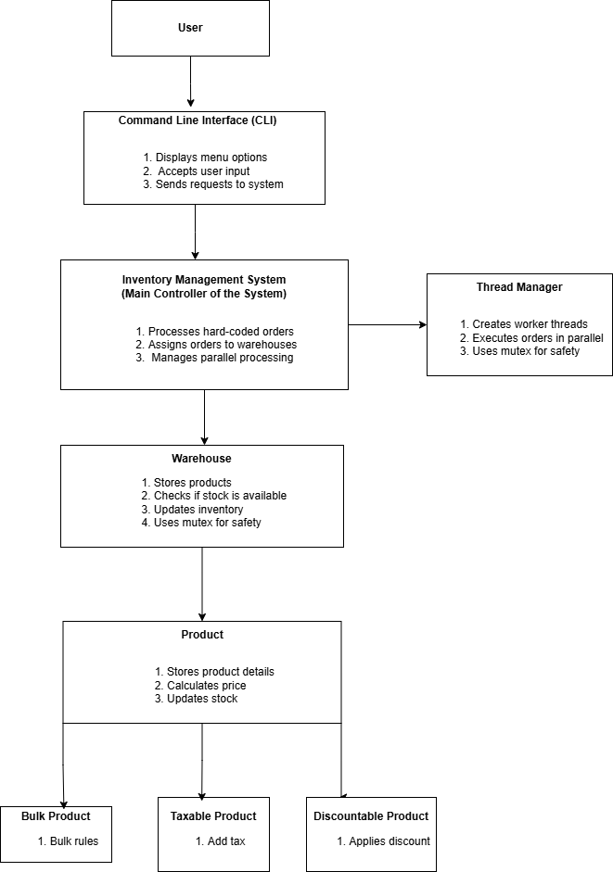

2.2 Description of Main Components

1. User Interface (CLI / main.cpp)
This is where the interaction of users and system begins. It provides a clear, menu-driven command-line interface through which;
staff can add or remove warehouses, manage products, and initiate order processing. It displays all outputs — including thread IDs, order results,
and updated stock levels — in a structured and readable format.

2. Inventory Management System (IMS)
The IMS is the central controller of the system. It manages all nine warehouse objects, routes staff requests to the correct warehouse,
and ensures thread-safe operations throughout. When an order is processed, the IMS identifies the appropriate warehouse, validates stock availability,
and delegates execution to the concurrency layer. It maintains overall system integrity and acts as the sole point of coordination between all components.

3. Warehouse
Each warehouse represents a physical storage unit located in a specific South African province.
Warehouses maintain their own product collections using std::map<int, shared_ptr<Product>>,
which guarantees unique product IDs and O(log n) lookups. They also track storage capacity, handle stock additions and removals,
and protect all inventory data with a dedicated std::mutex to prevent race conditions during concurrent updates.

4. Product Classes
The domain layer defines a polymorphic product structure. Product is an abstract base class defining common attributes (product ID, name, base price)
and declaring calculateFinalPrice() as a virtual method. Three derived classes override this method with their own pricing logic:
TaxableProduct applies a tax rate, DiscountProduct subtracts a discount percentage, and BulkProduct applies a discount only when the purchase quantity meets or exceeds a defined threshold.
This design enables the system to handle all product types uniformly through a single interface.

5. Order Processor
The concurrency layer handles real-time order execution. Each order runs in its own std::thread, enabling simultaneous processing of multiple requests.
The processor validates stock, deducts quantities, and records each outcome as SUCCESS or FAILED.
Two mutexes — inventoryMutex and consoleMutex — ensure that shared inventory data and console output remain consistent and free from race conditions.

2.4 Data Flow Between Components
The system follows a structured, top-down data-flow model that defines how requests move through the system from user input to final output.

Step 1 — Staff Interaction: A staff member interacts with the CLI, selecting an operation such as adding a product, viewing inventory, or processing orders. The CLI captures the input and forwards it to the IMS.
Step 2 — Request Delegation: The IMS validates the input and determines the appropriate action. Warehouse operations are routed to the relevant Warehouse object; product operations access the warehouse's internal Product map; order processing creates and dispatches order tasks to the concurrency layer.
Step 3 — Warehouse and Product Interaction: Each Warehouse searches its std::map using find() to locate products by ID. For stock modifications, the warehouse locks its inventoryMutex before updating quantities, then calls calculateFinalPrice() polymorphically through the product hierarchy.
Step 4 — Concurrent Order Processing: When orders are submitted, the Order Processor spawns a separate std::thread per order. Each thread independently locks the target warehouse's mutex, validates stock availability, updates or rejects the order, then unlocks and records the result. This allows up to 20 orders to execute simultaneously.
Step 5 — Shared Data Protection: The inventoryMutex protects warehouse stock during concurrent updates, while the consoleMutex prevents interleaved console output across threads. Together, these mechanisms guarantee data consistency and prevent negative stock values.
Step 6 — Result Display: Once all threads complete, results are aggregated and returned to the CLI, which displays each thread's ID, product details, warehouse location, and order status. This output provides visible confirmation of concurrent execution and correct system behaviour.

3. Class Design & OOP Structure

3.1 Class Descriptions

Class | Type | Key Attributes | Key Methods
Product | Abstract base class | productID, name, basePrice | calculateFinalPrice() [pure virtual], display(), getID(), getName(), getBasePrice()
TaxableProduct | Derived from Product | taxRate | calculateFinalPrice(): price * qty * (1 + taxRate)
DiscountProduct | Derived from Product | discountRate | calculateFinalPrice(): price * qty * (1 - discountRate)
BulkProduct | Derived from Product | threshold, bulkDiscount | calculateFinalPrice(): applies discount if qty >= threshold
Warehouse(one for each province) | Composition target | warehouseID, location, map<int,StockItem>, mutex | addProduct(), removeProduct(), decreaseStock(), displayAllProducts(), searchProduct()
InventoryManagementSystem | Manager | vector<shared_ptr<Warehouse>> | addWarehouse(), removeWarehouse(), displayAllWarehouses(), findWarehouse()
Order | Value object | orderID, province, vector<OrderItem>, status | addItem(), getItems(), setStatus(), getStatus()
OrderItem | Struct | productID, quantity | constructor

3.2 UML Class Diagram
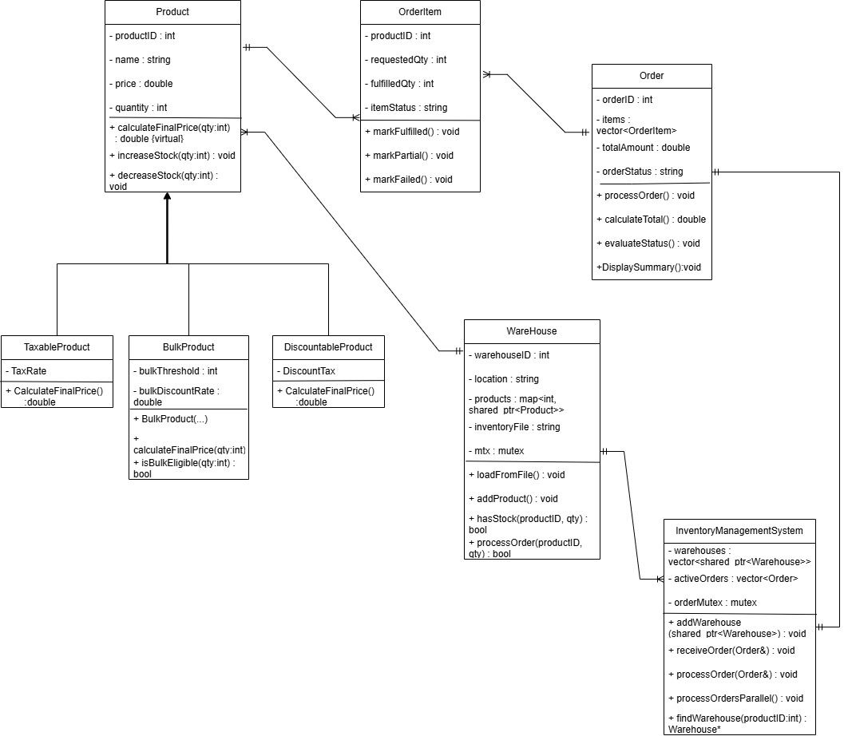

3.3 Inheritance and Polymorphism
Product (Abstract Base Class)
- Attributes: productID, name, basePrice
- Methods: calculateFinalPrice(int quantity) (pure virtual), display(), getID(), getName(), getBasePrice()
- Responsibility: Defines the common interface and attributes for all product types. As an abstract class, it cannot be instantiated directly; instead, it establishes a contract that all derived classes must implement their own pricing logic.

Product
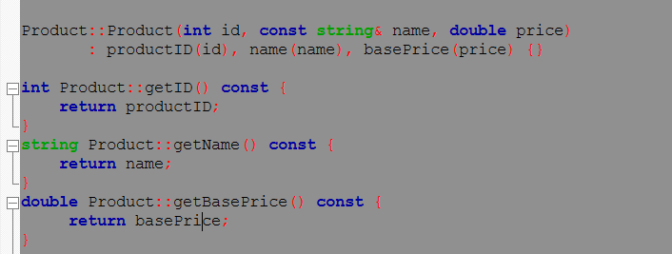

TaxableProduct: Adds Tax
• Attributes: taxRate
• Methods: Overrides calculateFinalPrice() to compute: price × quantity × (1 + taxRate)
• Responsibility: Models products subject to taxation (e.g., electronic goods). Demonstrates how derived classes specialize behavior while inheriting base attributes.
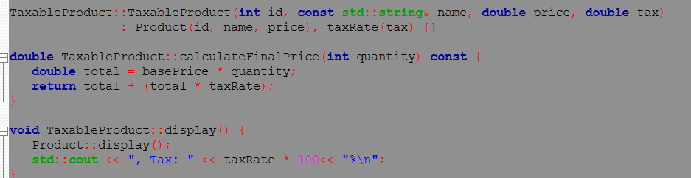

DiscountProduct: subtracts discount
- Attributes: discountRate.
- Methods: Overrides calculateFinalPrice() to apply discount percentage.
Responsibility: Models products with promotional discounts.
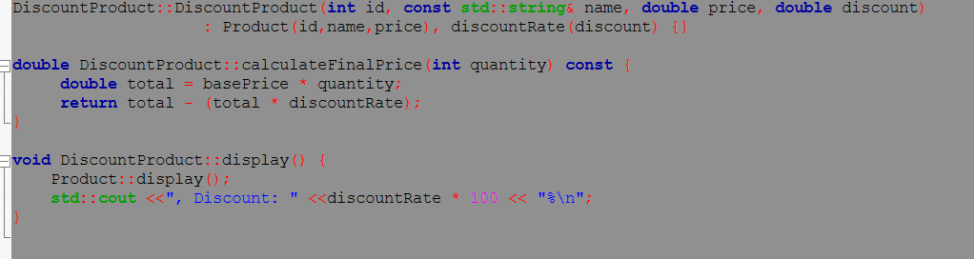

BulkProduct: discount only applied if qty >= threshold
• Attributes: threshold, bulkDiscount
• Methods: Overrides calculateFinalPrice() to apply bulkDiscount only if quantity ≥ threshold
• Responsibility: Models products eligible for bulk purchase discounts, enabling conditional pricing logic based on order volume.
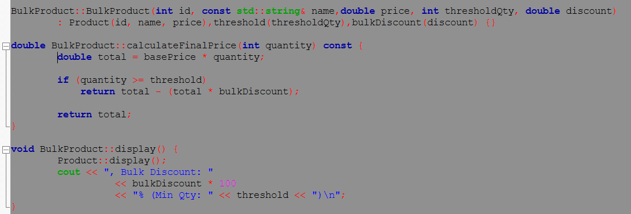

Warehouse
- Attributes: warehouseID, location (province), std::map<int, shared_ptr<Product>> (inventory), std::mutex (synchronization)
- Methods: addProduct(), removeProduct(), decreaseStock(), displayAllProducts(), searchProduct()
- Responsibility: Manages localized inventory for a specific province. Maintains product collections with thread-safe access through mutex protection. Serves as the data holder and primary point of synchronization in concurrent operations
.
InventoryManagementSystem (IMS)
- Attributes: std::vector<shared_ptr<Warehouse>> (collection of warehouses)
- Methods: addWarehouse(), removeWarehouse(), displayAllWarehouses(), findWarehouse()
- Responsibility: Central orchestrator and manager. Coordinates all warehouses, routes administrator requests, validates operations, and ensures system-wide integrity.

Order
- Attributes: orderID, province, std::vector<OrderItem>, status (SUCCESS/FAILED)
- Methods: addItem(), getItems(), setStatus(), getStatus()
- Responsibility: Represents a customer order to be processed. Encapsulates order details and outcome, processed concurrently by worker threads.

OrderItem (Struct)
- Attributes: productID, quantity
- Responsibility: Lightweight value object representing a single product request within an order. Enables orders to contain multiple product items.

Inheritance
The Product hierarchy demonstrates inheritance, with TaxableProduct, DiscountProduct, and BulkProduct extending the base Product class. This allows shared attributes and methods to be reused while enabling specialized behaviour.

Encapsulation
Each class encapsulates its own data and exposes only relevant methods. For example, Warehouse hides its internal product map and provides controlled access through addProduct() and searchProduct().

Polymorphism
- The calculateFinalPrice() method is declared as pure virtual in the base class and overridden in derived classes. When a warehouse iterates through its inventory and calls product->calculateFinalPrice(), the correct derived method executes automatically, demonstrating runtime polymorphism.

Virtual Functions: Design Justification
Virtual functions are essential to this architecture for three reasons:
- Correct Method Resolution: Without virtual functions, the compiler would resolve method calls at compile time based on the pointer type (shared_ptr<Product>), not the actual object type. This would mean all product objects would execute the base class calculateFinalPrice(), regardless of their true type, causing incorrect pricing calculations.
- Polymorphic Container Storage: The system stores all product types in a single std::map<int, shared_ptr<Product>>. Virtual functions enable a single loop to iterate through diverse product types and invoke their specialized behavior.
- Extensibility: New product types can be added in the future by simply creating new derived classes that override calculateFinalPrice(). The rest of the system remains unchanged.

4. Data Structures & STL Usage

4.1 Containers Used

1. std::vector<shared_ptr<Warehouse>>

The system stores the collection of warehouses using std::vector. Each element in the vector represents a warehouse object containing its own product stock levels, storage capacity, and product collection. The use of vector allows easy indexing, dynamic sizing, and sequential access. std::vector is compatible with std::find_if for searching. For this, std::vector offers a simple and efficient container, since the number of warehouses is fixed.

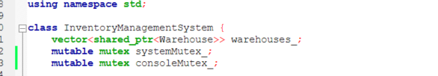

2. std::map<int, shared_ptr<Product>>

Products are stored in each warehouse using std::map, where the value represent product item, and the key is a unique Product ID. The use of std::map is good for product storage since it ensures unique keys, supports efficient searching, and it ensures that duplicate product IDs cannot exist within the same warehouse.

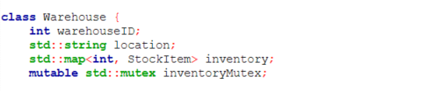

4.2 STL Algorithms
std::find_if
This is used when we are looking for a warehouse using its ID.
This function searches the list and picks the warehouse that matches the entered ID.
This function makes the code more readable.
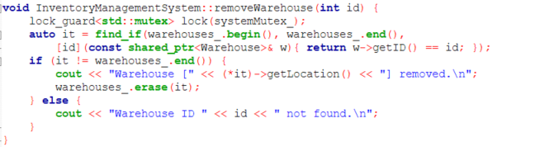

std::map::find
This is used when we are looking for a product within a warehouse.
Because products are stored in a map data structure, this function enables the system to easily find a product based on its key.
This is much faster than manually scanning each product one by one, especially when there are many products.
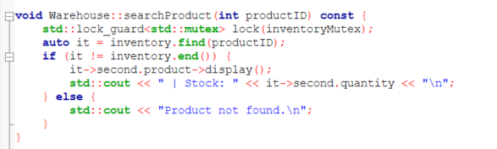

std::sort
This is used when we are looking to sort products.

For example, products can be sorted based on their price or quantity.
This makes it easier for the user to display products in an organized way.

Safety
- STL containers automatically manage memory and prevent unsafe pointer arithmetic
- shared_ptr enforces proper ownership semantics; objects are destroyed only when the last reference is released
- No manual new/delete operations means no memory leaks or double-free bugs
- Bounds checking is implicit (e.g., map::find() returns .end() for missing keys, not undefined behavior)

Performance
- std::map provides O(log n) complexity for lookups, far superior to linear search for large inventories
- std::vector offers cache-friendly sequential memory layout, improving CPU cache hits
- STL algorithms are highly optimized by compiler vendors; hand-written loops rarely match their performance.

5. Concurrency Design

5.1 Threading Model
StationaryHub uses multiple threads to process orders. When the user selects Process All Orders, the system creates threads for each order. After creating all threads, the program calls join() on each thread. This means that all orders will run at the same time. This makes processing faster.

5.2 Shared Resources and Synchronization
The main shared resource is the warehouse inventory:
std::map<int, StockItem>
Many threads may access the inventory at the same time. To prevent this problem, each warehouse has a std::mutex called inventoryMutex. Before reading or changing stock, the program uses:
std::lock_guard<std::mutex>
This automatically locks and unlocks when the function ends. This keeps inventory safe.

5.3 Preventing Race Conditions
To prevent race conditions, the program locks the inventory while it checks if the product exists, checks if enough stock is available, and reduces the stock. Because all steps happen inside one locked section, no other thread can interrupt. Stock cannot go below zero and data stays correct.

5.4 Console Output Protection
Many threads print to the console. Without protection, messages can mix together. A second mutex called consoleMutex is used. Before printing with std::cout, the thread locks this mutex. This ensures one full message prints at a time and output stays clear.
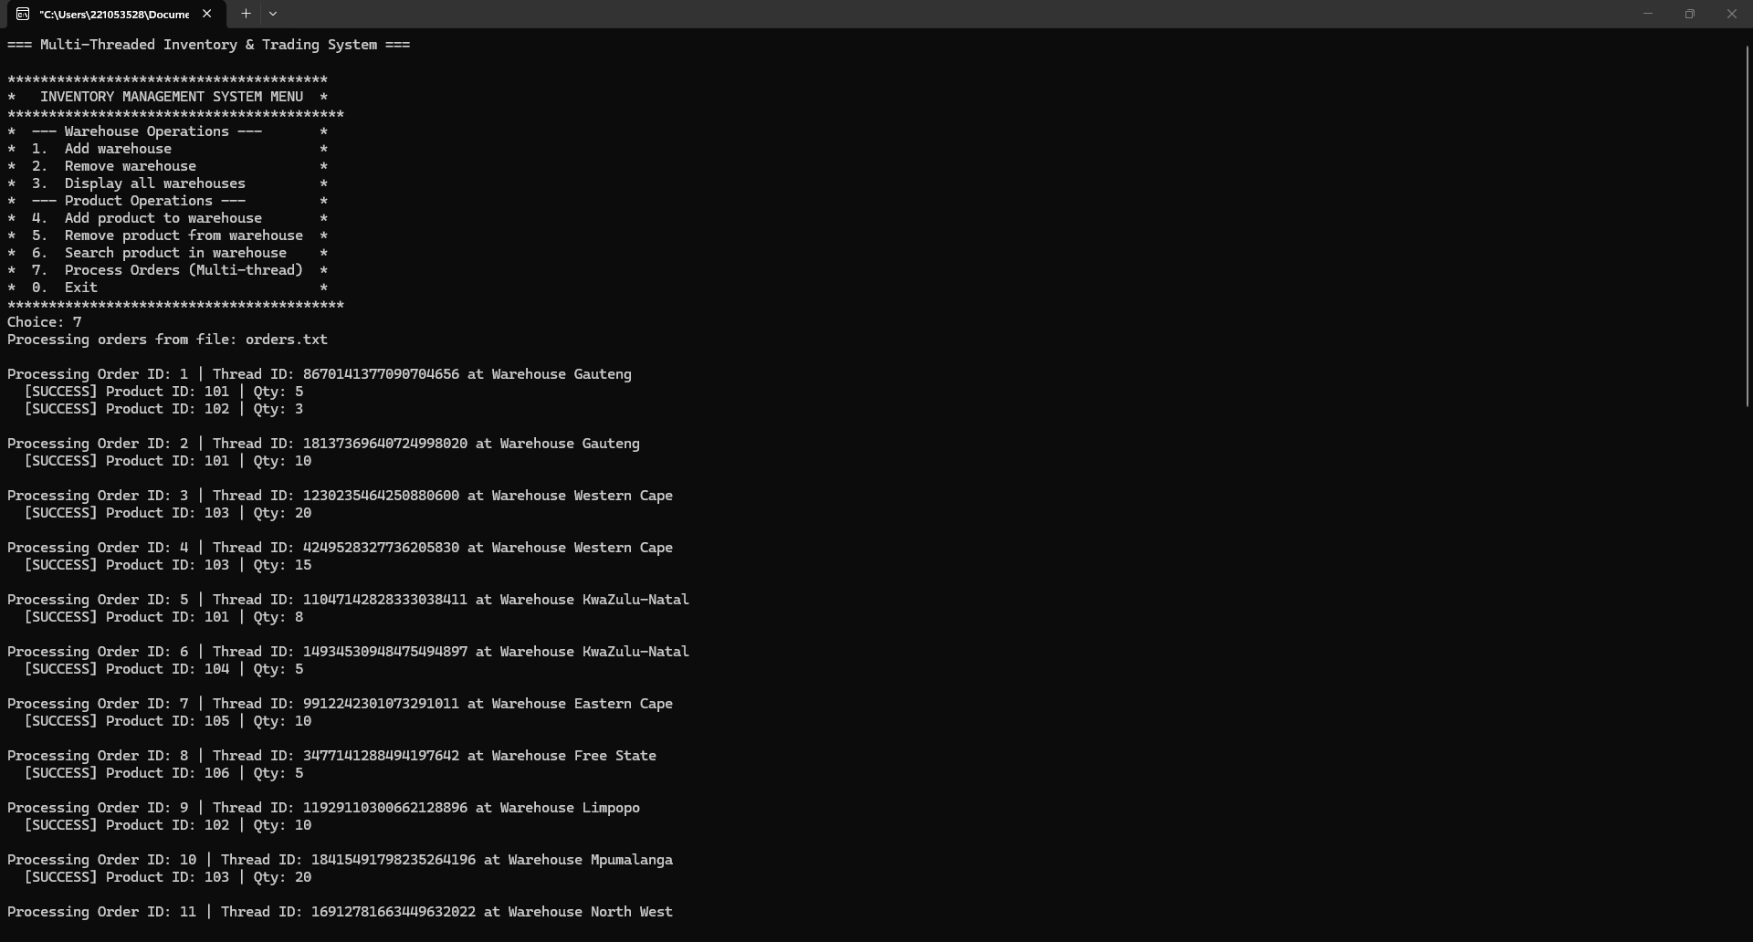

6. Memory Management Strategy
The system uses smart pointers only. There are no raw new or delete statements anywhere in the program. This reduces errors and make the system more stable.

6.1 Smart Pointer Usage
std:: shared_ptr<Product> is used because products may be shared in different parts of the system, such as the warehouse inventory and order processing. The product will stay in memory as long as it is being used.
std::shared_ptr<Warehouse> is used because warehouses contain a std::mutex, and objects with a mutex cannot be copied. Using shared_ptr allows warehouses to be safely stored and accessed without copy problems. std::shared_ptr
std::shared_ptr<Order> is used std::shared_ptr<Order> is used to ensure orders stay in memory while threads are running. Even if multiple parts of the system access the same order, it remains valid until processing is complete.

6.2 6.2 Difference Between shared_ptr and unique_ptr

std::shared_ptr

Allows multiple owners of the same object.

Uses reference counting to track how many pointers reference the object.

Object is destroyed only when the last shared_ptr goes out of scope.

Ideal for products and warehouses that need to be accessed by multiple components simultaneously.

std::unique_ptr

Provides exclusive ownership of an object.

Cannot be copied, only moved.

Object is destroyed when the unique_ptr goes out of scope.

Suitable for temporary or single-owner objects, though StationaryHub primarily uses shared_ptr due to shared access requirements.

6.3 Ownership Semantics
Ownership semantics are carefully designed:
- Shared ownership: Products and warehouses are shared across the Inventory Management System, order threads, and display functions.
- Exclusive ownership: Temporary objects (e.g., configuration loaders) may use unique_ptr to ensure strict ownership and automatic cleanup.
- Automatic destruction: When the last smart pointer referencing an object goes out of scope, the object is destroyed safely without manual intervention.

6.4 Preventing Memory Leaks
Memory leaks are prevented by:
- Eliminating raw pointers: No new or delete operations are used anywhere in the system.
- Automatic cleanup: Smart pointers automatically free memory when reference counts reach zero.
- Thread safety: Orders and warehouses remain valid until all threads complete, preventing premature deletion.
- End of program cleanup: When main() terminates, all smart pointers go out of scope, ensuring that all dynamically allocated objects (Products, Warehouses, Orders) are destroyed correctly.

7. User Interface Design

7.1 CLI Menu Structure
The application presents a Command-Line Interface (CLI) that allows administrators to interact with the system. The CLI is menu-driven, ensuring usability and clear navigation even in a text-based environment, the system responds with clear prompts and confirmation messages.
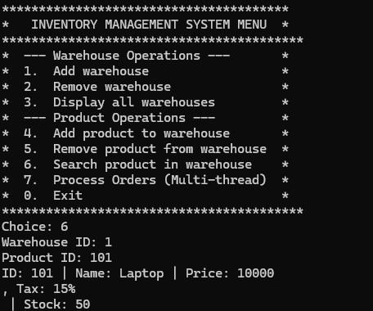_

- Warehouse Operations
  - Add a new warehouse
  - Remove an existing warehouse
  - Display all warehouses and their inventories
- Product Operations
  - Add a new product (Taxable, Discount, Bulk)
  - Remove a product by ID
  - Search for a product by ID
  - Sort products by price or quantity
- Order Processing
  - Process all orders concurrently (20 threads)
  - Display order outcomes (SUCCESS/FAILED)
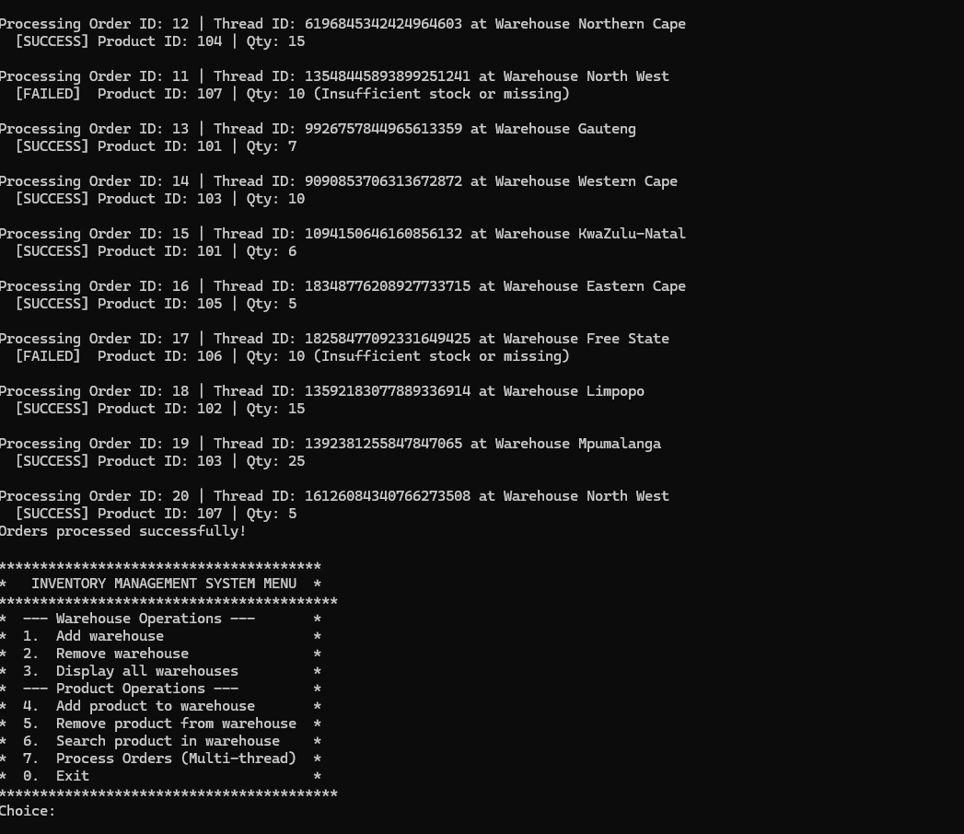

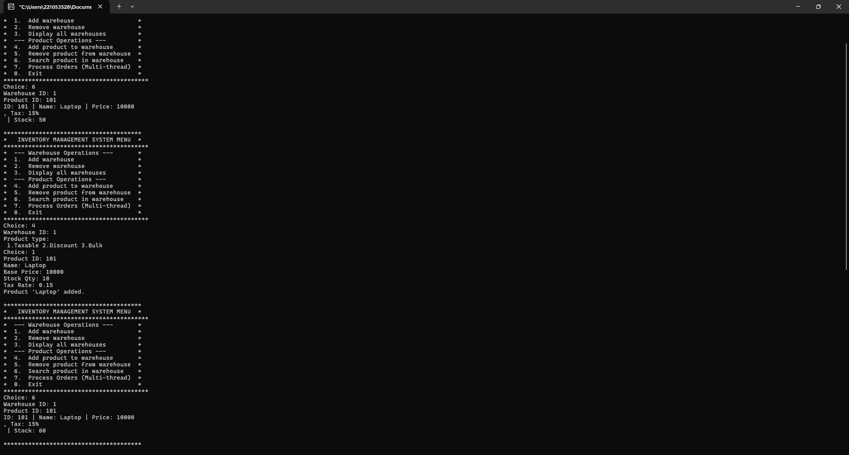

8. System Functionality and Testing

8.1 Test Scenarios
(Adding a Product)
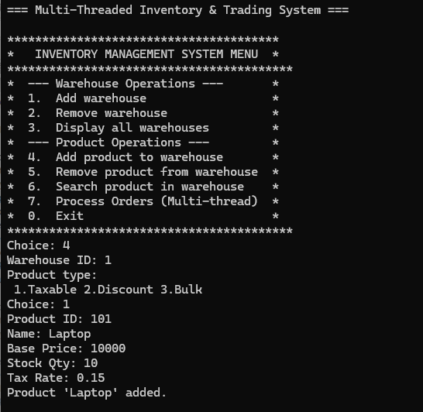

Edge Case: Insufficient Stock
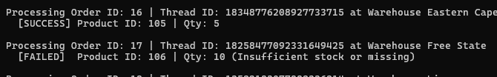

9.Performance & Limitations

9.1 Observed Performance Characteristics
Concurrency Benefits:
Up to N orders processed in parallel. Total processing time ≈ max(order processing time) rather than sum. Warehouse-level mutexes allow simultaneous access to different warehouses.

Lock Contention:
When many orders target the same product, mutex contention increases. All threads queue for the inventoryMutex of that warehouse. Processing becomes more sequential (bottleneck effect).

9.2 Known Limitations
9 fixed warehouses: Adding warehouses requires modifying main() and recompilation. No database persistence: Inventory is loaded from CSV at startup but changes aren't saved. Synchronous menu: Admin must wait for all orders to complete before returning to menu. No thread pooling: Creates new threads for each order.

10.Challenges & Solutions
10.1 Technical Challenges Encountered
Challenge 1: Race Conditions in Inventory
Initial attempts to update stock without proper synchronization led to incorrect inventory values. Two threads could both see the same stock value and both process orders, reducing it only once instead of twice.

Solution:
Enclose all stock validation and modification in a std::lock_guard critical section. Only one thread can execute the validation-update sequence at a time, ensuring stock values remain correct.

Challenge 2: Interleaved Console Output
Multiple threads printing simultaneously created garbled output with text from different orders mixed together, making it impossible to read results.

Solution:
Implement consoleMutex to serialize all output. Each thread locks the console mutex before printing, ensuring its entire message completes atomically before the next thread can print.

Challenge 3: Memory Management
Early attempts with raw pointers led to memory leaks and use-after-free bugs when objects were deleted prematurely or forgotten entirely.

Solution:
Adopted std::shared_ptr exclusively throughout the system. Automatic reference counting ensures objects are destroyed only when all references are released, eliminating manual memory management errors.

Challenge 4: Polymorphic Pricing Without Virtual Functions
Attempting to store different product types in a vector without virtual functions meant only base class pricing logic executed for all product types.

Solution:
Use virtual functions and shared pointers to enable polymorphic dispatch. When calculateFinalPrice() is called through a shared_ptr<Product>, the correct derived class method executes at runtime based on the actual object type.

10.2 Key Learning Outcomes
Concurrency is Complex: Simple logic becomes difficult under concurrent execution. Proper synchronization with mutexes and critical sections is essential. Smart Pointers are Essential: They eliminate entire classes of bugs (memory leaks, use-after-free, dangling pointers). STL + C++ Concepts: Using std::vector, std::map, and proper algorithms makes code clearer, safer, and more maintainable. Polymorphism Requires Virtual Functions: Without them, the benefits of OOP (code reuse, flexibility, extensibility) are lost. Mutual Exclusion Must Be Granular: Coarse-grained locking reduces concurrency; fine-grained locking (per-warehouse) maximizes throughput while preventing race conditions.

12.Conclusion
12.1 Final System Summary
StationaryHub successfully demonstrates a complete, production-quality inventory management system built with modern C++ principles. The system achieved all COMP315 project requirements: multi-threaded order processing with concurrent execution; thread-safe inventory management with mutex synchronization; polymorphic product hierarchy with inheritance and virtual functions; STL container and algorithm usage; smart pointer memory management with no raw pointers; clear CLI interface with menu-driven operations; and compilation without warnings.

12.2 Key Technical Achievements
Correct Concurrency: Multiple orders processed simultaneously without data corruption or race conditions. Robust Memory Management: Zero memory leaks; automatic cleanup via smart pointers. Clean OOP Design: Polymorphic product hierarchy demonstrates inheritance, encapsulation, and runtime polymorphism. Efficient Data Access: O(log n) product lookups in large inventories via std::map. Scalable Architecture: Nine warehouses can operate independently; system can handle large numbers of concurrent orders.

12.3 Lessons Learned
Concurrency requires discipline in mutex placement and critical section definition. STL is powerful and eliminates hundreds of lines of error-prone code. Virtual functions are essential for polymorphism to function correctly. Smart pointers simplify memory management and increase code safety. Testing concurrent code is challenging; race conditions are hard to reproduce and debug; careful analysis is essential.

